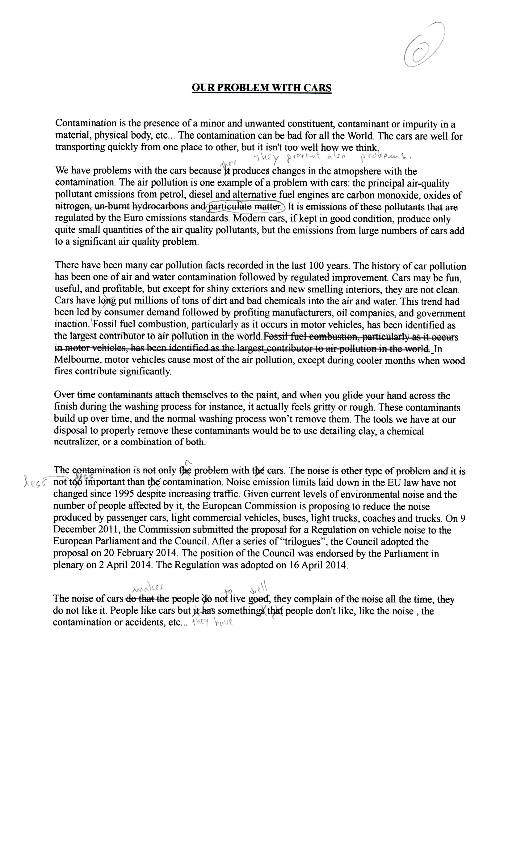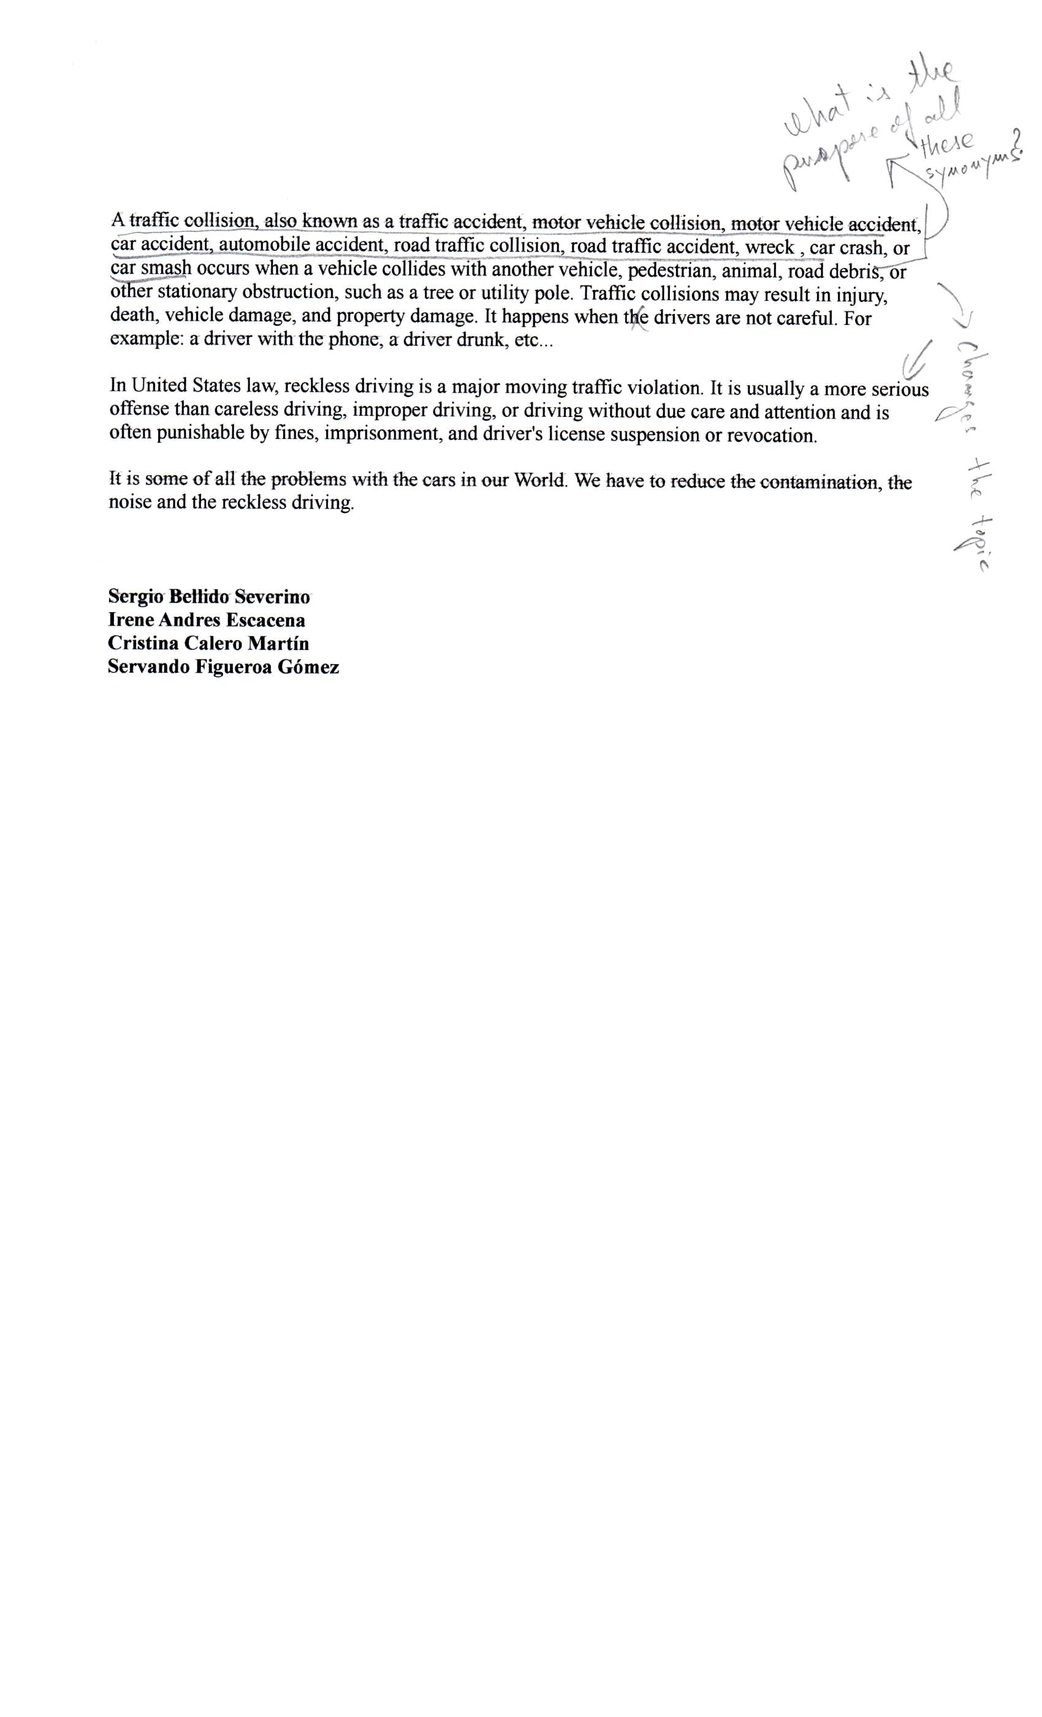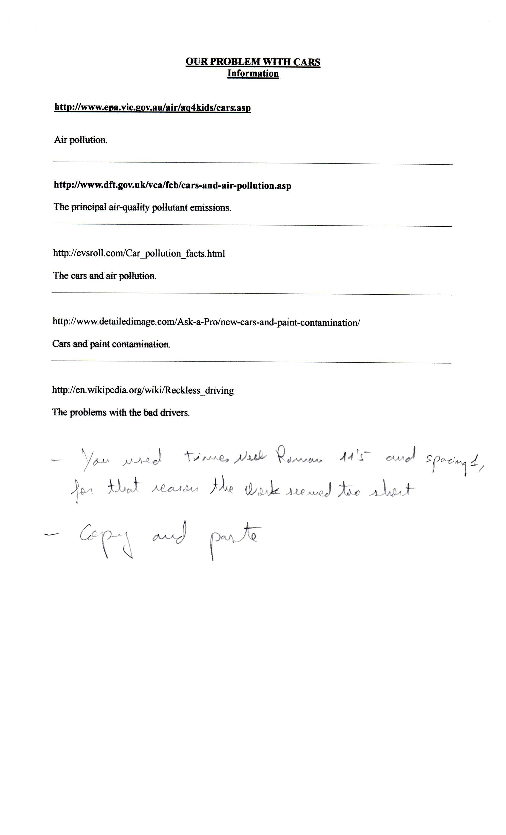

Extension essay with Times New Roman 12 and 1,5 spacing is two pages.
OUR PROBLEM WITH CARS
Contamination is the presence of a minor and unwanted constituent, contaminant or impurity in a material, physical body, etc ... The contamination can be bad for all the World. The cars are well for transporting quickly from one place to other, but it isn't too well how we think.

We have problems with the ears because it produces ehanges in the atmopshere with the
eontamination. The air pollution is one example of a problem with cars: the principal air-quality pollutant emissions from petrol, diesel and alternative fuel engines are carbon monoxide, oxides of nitrogen, un-burnt hydrocarbons and particulate matter. Tt is emissions ofthese pollutants that are regulated by the Euro emissions standards. Modern cars, if kept in good condition, produce only quite small quantities of the air quality pollutants, but the emissions from large numbers of cars add to a significant air quality problern.
There have been many car pollution facts recorded in the last 100 years. The history of car pollution has be en one of air and water contamination followed by regulated improvement. Cars may be fun, useful, and profitable, but except for shiny exteriors and new smelling interiors, they are not c1ean. Cars have long put millions of tons of dirt and bad chemicals into the air and water. This trend had been led by consumer demand followed by profiting manufacturers, oil companies, and government inaction. Fossil fuel combustion, particularly as it occurs in motor vehic1es, has been identified as the targcst contributor to air poñunon in the wotld.FossH fuel combusnon, particuíarty as it occurs in motor vehic1es, has been identified as the largestcontributor to air pollution in the world.In Melbourne, motor vehic1es cause most ofthe air pollution, exeept during cooler months when wood fires contribute significantly.
Over time contaminants attach themselves to the paint, and when you glide your hand across the finish during the washing proeess for instance, it aetually feels gritty or rough. These eontaminants build up over time, and the normal washing process won't remove them. The tools we have at our disposal to properly remove these contaminants would be to use detailing c1ay, a chemical neutralizer, or a eombination of both.
The oontamination is not only the problem with the cars. The noise is other type of problem and it is not too important than the contamination. Noise emission limits laid down in the EU law have not changed since 1995 despite increasing traffie. Given current levels of environmental noise and the number of people affected by it, the European Commission is proposing to reduce the noise produeed by passenger cars, light commercial vehic1es, buses, light trucks, coaches and trucks. On 9 December 2011, the Commission submitted the proposal for a Regulation on vehic1e noise to the European Parliament and the Couneil. After a series of "trilogues", the Council adopted the proposal on 20 February 2014. The position ofthe Council was endorsed by the Parliarnent in plenary on 2 Apri12014. The Regulation was adopted on 16 Apri12014.
The noise of oars do that the people do not live good, they complain of the noise all the time, they do not like it. People like cars but it has somethings that people don't like, like the noise , the contamination or accidents, etc ...

A traffic oollision, also known as a traffie aeeident, motor vehicle eollision, motor vehicle aeeident, ear aecident, automobile aceident, road traffie eoIlision, road traffie aeeident, wreek , ear erash, or ear smash oeeurs when a vehicle eollides with another vehicle, pedestrian, animal, road debris, or other stationary obstruetion, sueh as a tree or utility poleo Traffie eollisions may result in injury, death, vehicle damage, and property damage. It happens when the drivers are not eareful. For example: a driver with the phone, a driver drunk, ete ...
In United States law, reekless driving is a major moving traffie violation. It is usually a more serious offense than eareless driving, improper driving, or driving without due eare and attention and is often punishable by fines, imprisonment, and driver's license suspension or revoeation.
It is some of all the problems with the ears in our World. We have to reduce the contamination, the noise and the reckless driving.

Copy and paste:
http://www.dft.gov.uk/vca/fcb/cars-and-air-pollution.asp
Modern cars, if kept in good condition, produce only quite small quantities of the air quality pollutants, but the emissions from large numbers of cars add to a significant air quality problem.
http://evsroll.com/Car_pollution_facts.html
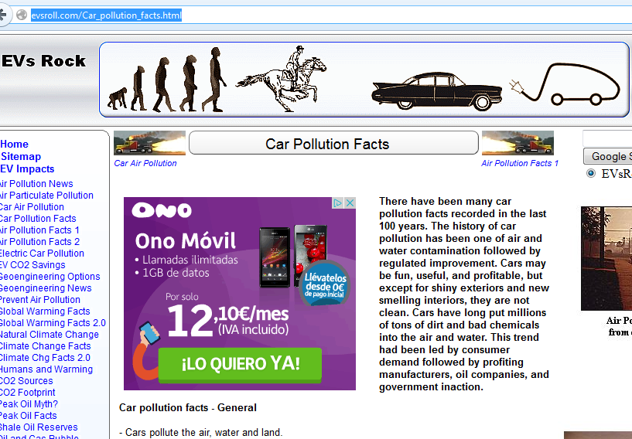

etc.

