UNIT 2
TECHNICAL DRAWING: DIMENSIONING
- Dimensions.
Set of lines which indicate the measurements of the objects represented in a drawing. These lines are thinner than the lines representing the object.

Dimensioning elements:
* Extension lines. Perpendicular to the side which gives the measurements.
* Dimension lines. Parallel to the side.
* Arrow heads. At the edges of the dimension lines.
* Figures. They indicate the measurements of the side. They are situated over the dimension line, if this is horizontal, or to its left and in an upwards direction, if it is vertical.

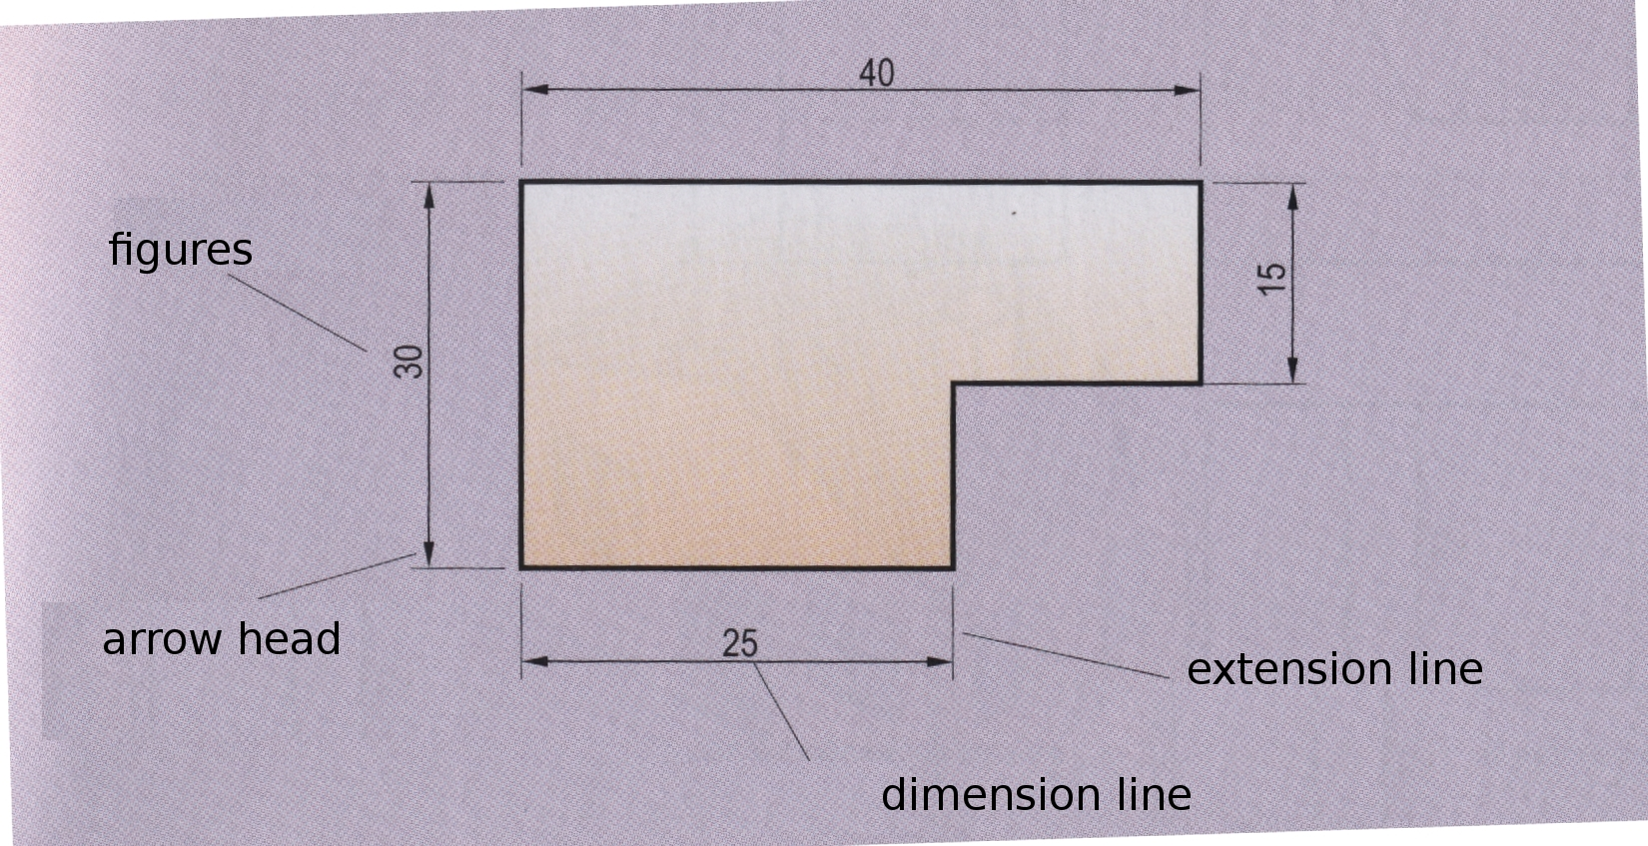
Ed. Donostierra. ESO I (2008). pag.25

http://www.tecno12-18.com/mud/acota/acota.asp (Slides 1-24. Select “Versión dinámica)

Meaning of each figure:
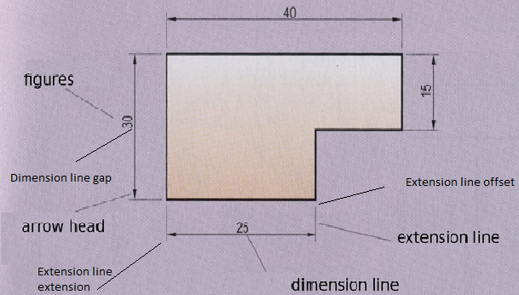

- Exercise 1: Make the following exercise with QCad. Divide horizontally an A4 format with title box, then draw one of the figures in each of the resulting spaces and dimension them. Consider each square to represent 4'5 mm.


